Front End Engineering-II

Project Report Semester-IV (Batch-2022)

Title of the Project: -

ColorVerse



**Supervised By: Submitted By:**

Raveesh Samkaria Sparsh Mittal

Roll Number: -2210990865

Group - 13

## Department of Computer Science and Engineering Chitkara University Institute of Engineering & Technology,

**Chitkara University, Punjab**

FEE-II, 22CS0014

1

# Abstract

This project report outlines the creation of ColorVerse, an innovative web platform driven by HTML, JavaScript, and Tailwind CSS, engineered to redefine the process of color palette creation. Users can explore an extensive array of color combinations, ranging from harmonious to contrasting schemes. The intuitive interface empowers users to effortlessly generate, customize, and download their preferred palettes in various formats. With its emphasis on user experience and versatility, ColorVerse caters to the diverse needs of designers, developers, and enthusiasts, ushering in a new era of creativity and efficiency in digital design.

# Table of Contents

|  |  |  |
| --- | --- | --- |
| **Sr.no** | **Section** | **Page No** |
| **1.** | Introduction | 4 |
| **2.** | Problem Statement | 5 |
| **3.** | Technical Details | 6 |
| **4.** | File Structure | 7 |
| **5.** | Result | 8 |
| **6.** | References | 22 |

**Introduction**

In today's digital realm, where visual aesthetics reign supreme, the ability to harness the power of color effectively is a cornerstone of captivating design. Whether crafting a website, designing a logo, or developing marketing materials, the strategic use of color can significantly impact user engagement and brand perception. This report chronicles the development and implementation of a cutting-edge color palette generator website, named ColorVerse, utilizing a dynamic blend of HTML, JavaScript, and Tailwind CSS.

ColorVerse emerges as a pivotal tool for designers and creatives, providing them with a versatile platform to effortlessly generate captivating color palettes tailored to their unique vision and requirements. The website's intuitive interface and seamless functionality aim to streamline the palette creation process, empowering users to explore a diverse spectrum of colors and download their custom palettes with ease.

This introduction sets the stage for the project, emphasizing the significance of color in digital design and the pivotal role of innovative tools like ColorVerse in empowering creators. Subsequent sections will delve into the technical intricacies of the website development process, highlighting key features, design considerations, and implementation strategies specific to the color palette generation functionality. Additionally, the report will address any challenges encountered during the project and outline effective solutions devised to overcome them, providing valuable insights for future endeavors in color palette generator development.

# Problem Statement

Designers and creatives often struggle with time-consuming and inefficient methods of generating captivating color palettes, hindering their ability to unleash their full creative potential. Manual selection and experimentation processes limit exploration of diverse color combinations, while the absence of intuitive tools exacerbates the challenge.

In today's digital landscape, the demand for visually appealing content across platforms is increasing. This highlights the urgent need for a solution that streamlines palette creation, empowering designers to create compelling visuals efficiently.

The primary objective of this project is to develop ColorVerse, a user-friendly color palette generator website. By leveraging HTML, JavaScript, and Tailwind CSS, ColorVerse aims to revolutionize color selection, fostering creativity and efficiency in the digital design workflow.

Through comprehensive research and meticulous design, ColorVerse seeks to deliver a solution that sets a new standard for palette generation. By providing users with a seamless platform for exploring, customizing, and downloading captivating color palettes, ColorVerse aims to elevate the digital design experience and inspire creativity worldwide.

# Technical Details

ColorVerse is developed using a powerful combination of HTML, Tailwind CSS, and JavaScript to ensure seamless functionality and an intuitive user experience.

* **HTML:** As the backbone of the website, HTML (Hypertext Markup Language) is used to structure the content and layout of ColorVerse. HTML provides the foundation for organizing elements such as headers, navigation menus, color palette previews, and download buttons. By structuring the content with HTML, ColorVerse ensures accessibility and compatibility across different devices and browsers.
* **Tailwind CSS:** Tailwind CSS is utilized to style and design the visual elements of ColorVerse. Tailwind CSS offers a utility-first approach, allowing for rapid prototyping and customization through pre-defined utility classes. With Tailwind CSS, ColorVerse achieves a sleek and modern aesthetic while maintaining flexibility and scalability. From typography and spacing to colors and responsiveness, Tailwind CSS streamlines the styling process, ensuring consistency and coherence throughout the website.
* **JavaScript:** JavaScript serves as the dynamic engine powering the interactive features of ColorVerse. Through JavaScript, ColorVerse implements functionalities such as real-time color palette generation, user interaction handling, and dynamic content updates. JavaScript enables users to customize and fine-tune their color palettes with ease, providing instant feedback and a seamless user experience. Additionally, JavaScript is utilized to facilitate the downloading of generated color palettes, enhancing the website's usability and functionality.

By leveraging HTML, Tailwind CSS, and JavaScript, ColorVerse delivers a robust and user-friendly color palette generator that empowers designers and creatives to explore, create, and download captivating color schemes effortlessly. The seamless integration of these technologies ensures optimal performance, accessibility, and interactivity, cementing ColorVerse's position as a cutting-edge tool for digital design.

# File Structure: -

The file structure of ColorVerse adheres to a minimalist approach, comprising essential files to ensure efficient organization and streamlined development. Here's an overview of the file structure:

1. **index.html:** The heart of ColorVerse, index.html serves as the main entry point for the website. This file contains the HTML markup responsible for structuring the content and layout of ColorVerse. Elements such as navigation menus, color palette previews, and download buttons are defined within index.html, providing users with a seamless browsing experience.
2. **script.js:** The JavaScript functionality of ColorVerse is encapsulated within the script.js file. Here, essential functionalities such as real-time color palette generation, user interaction handling, and dynamic content updates are implemented. script.js ensures the interactivity and responsiveness of ColorVerse, enhancing the overall user experience.
3. **tailwind.config.js:** Tailwind CSS customization and configuration are managed through the tailwind.config.js file. This file allows developers to customize the default configuration of Tailwind CSS according to the specific requirements of ColorVerse. By defining custom colors, typography, breakpoints, and other design parameters, tailwind.config.js ensures consistency and coherence in the visual design of ColorVerse.

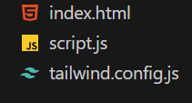

# Result

Webpage Screenshots: -

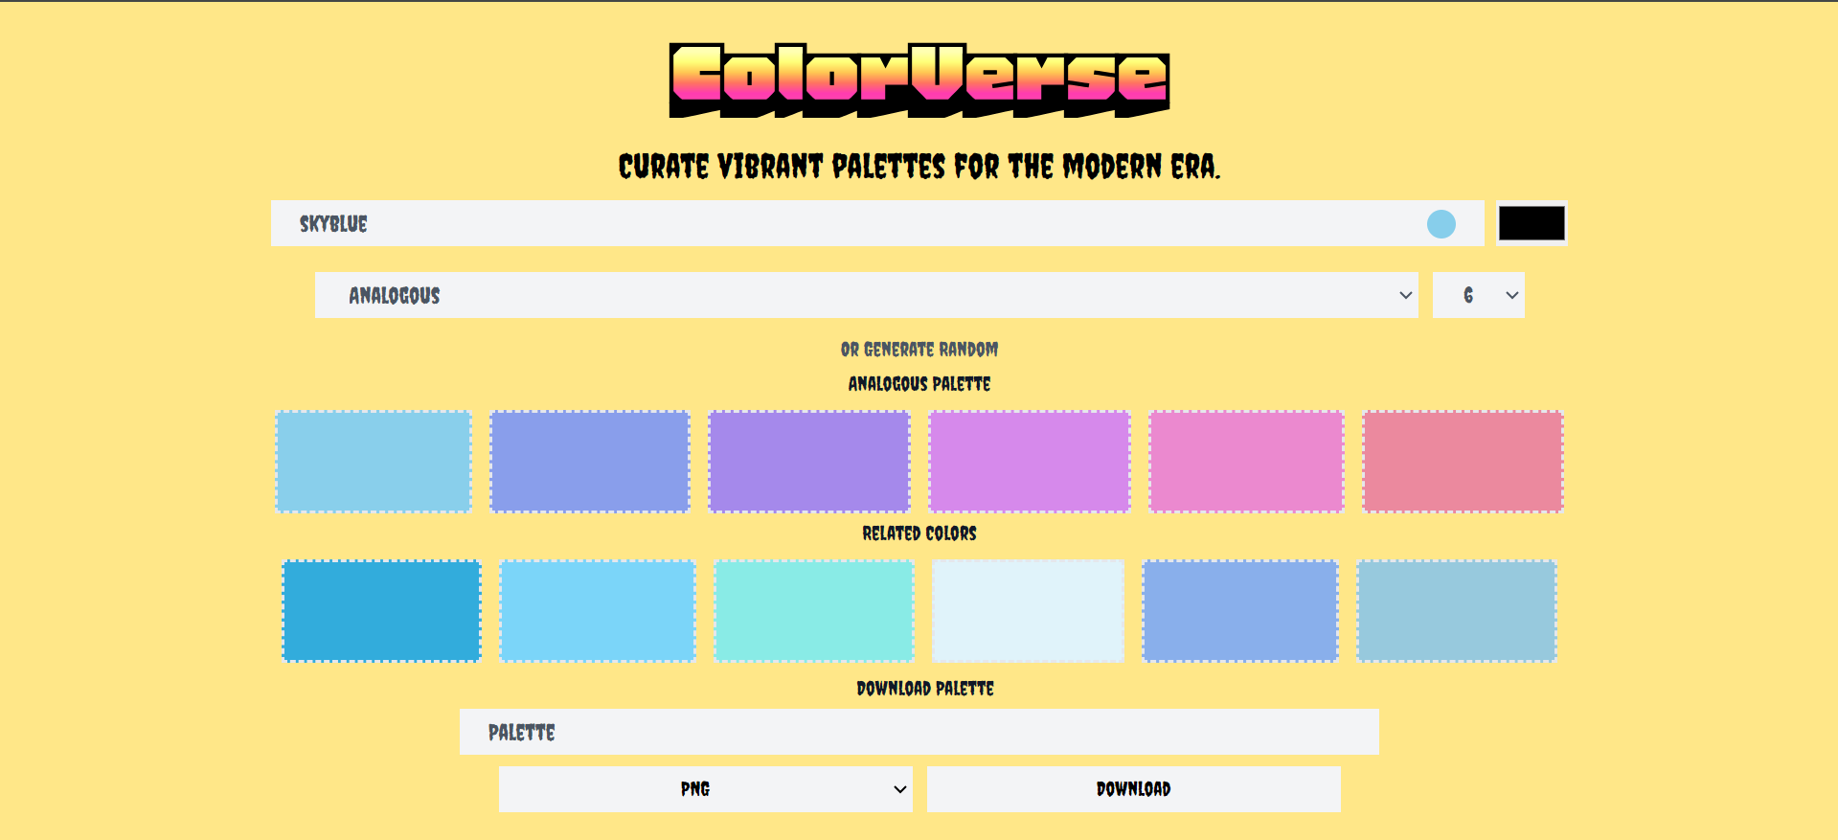

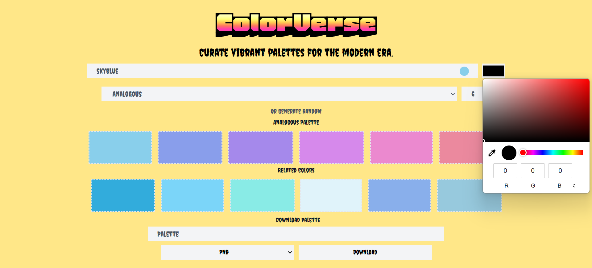

**Code:-**

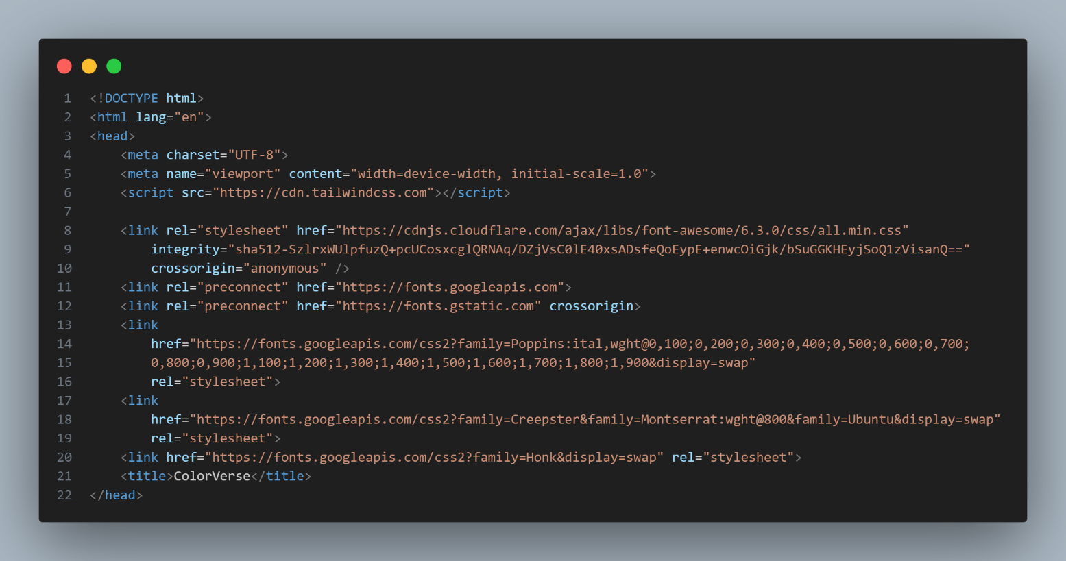

**Figure 1 HTML- Head**

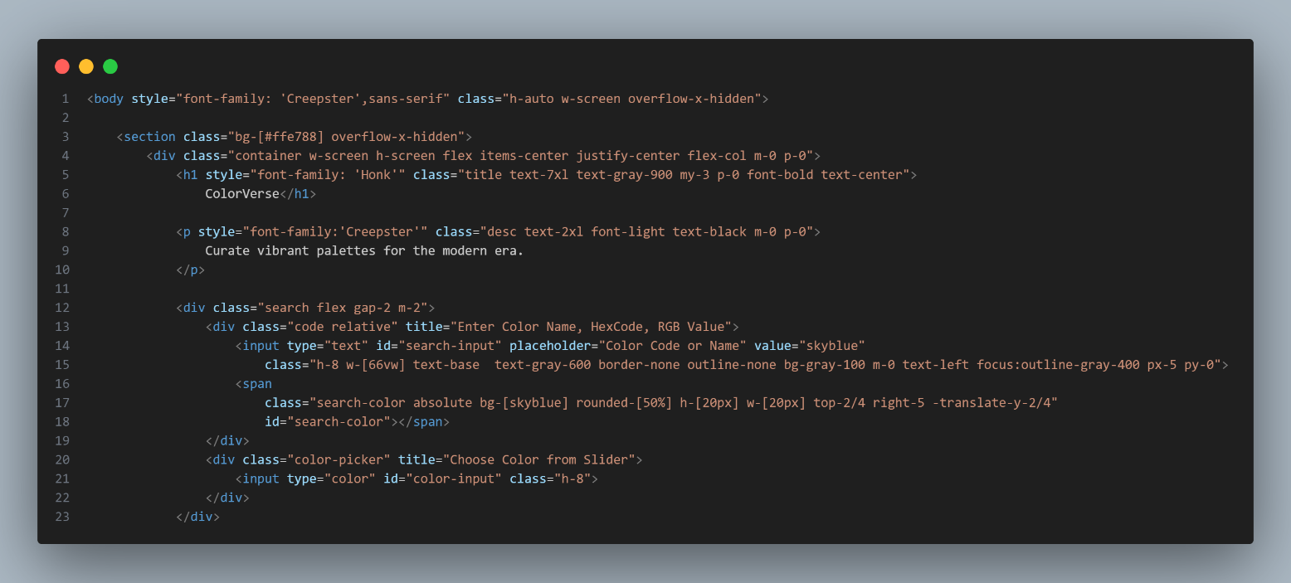

**Figure 2 HTML - Body**

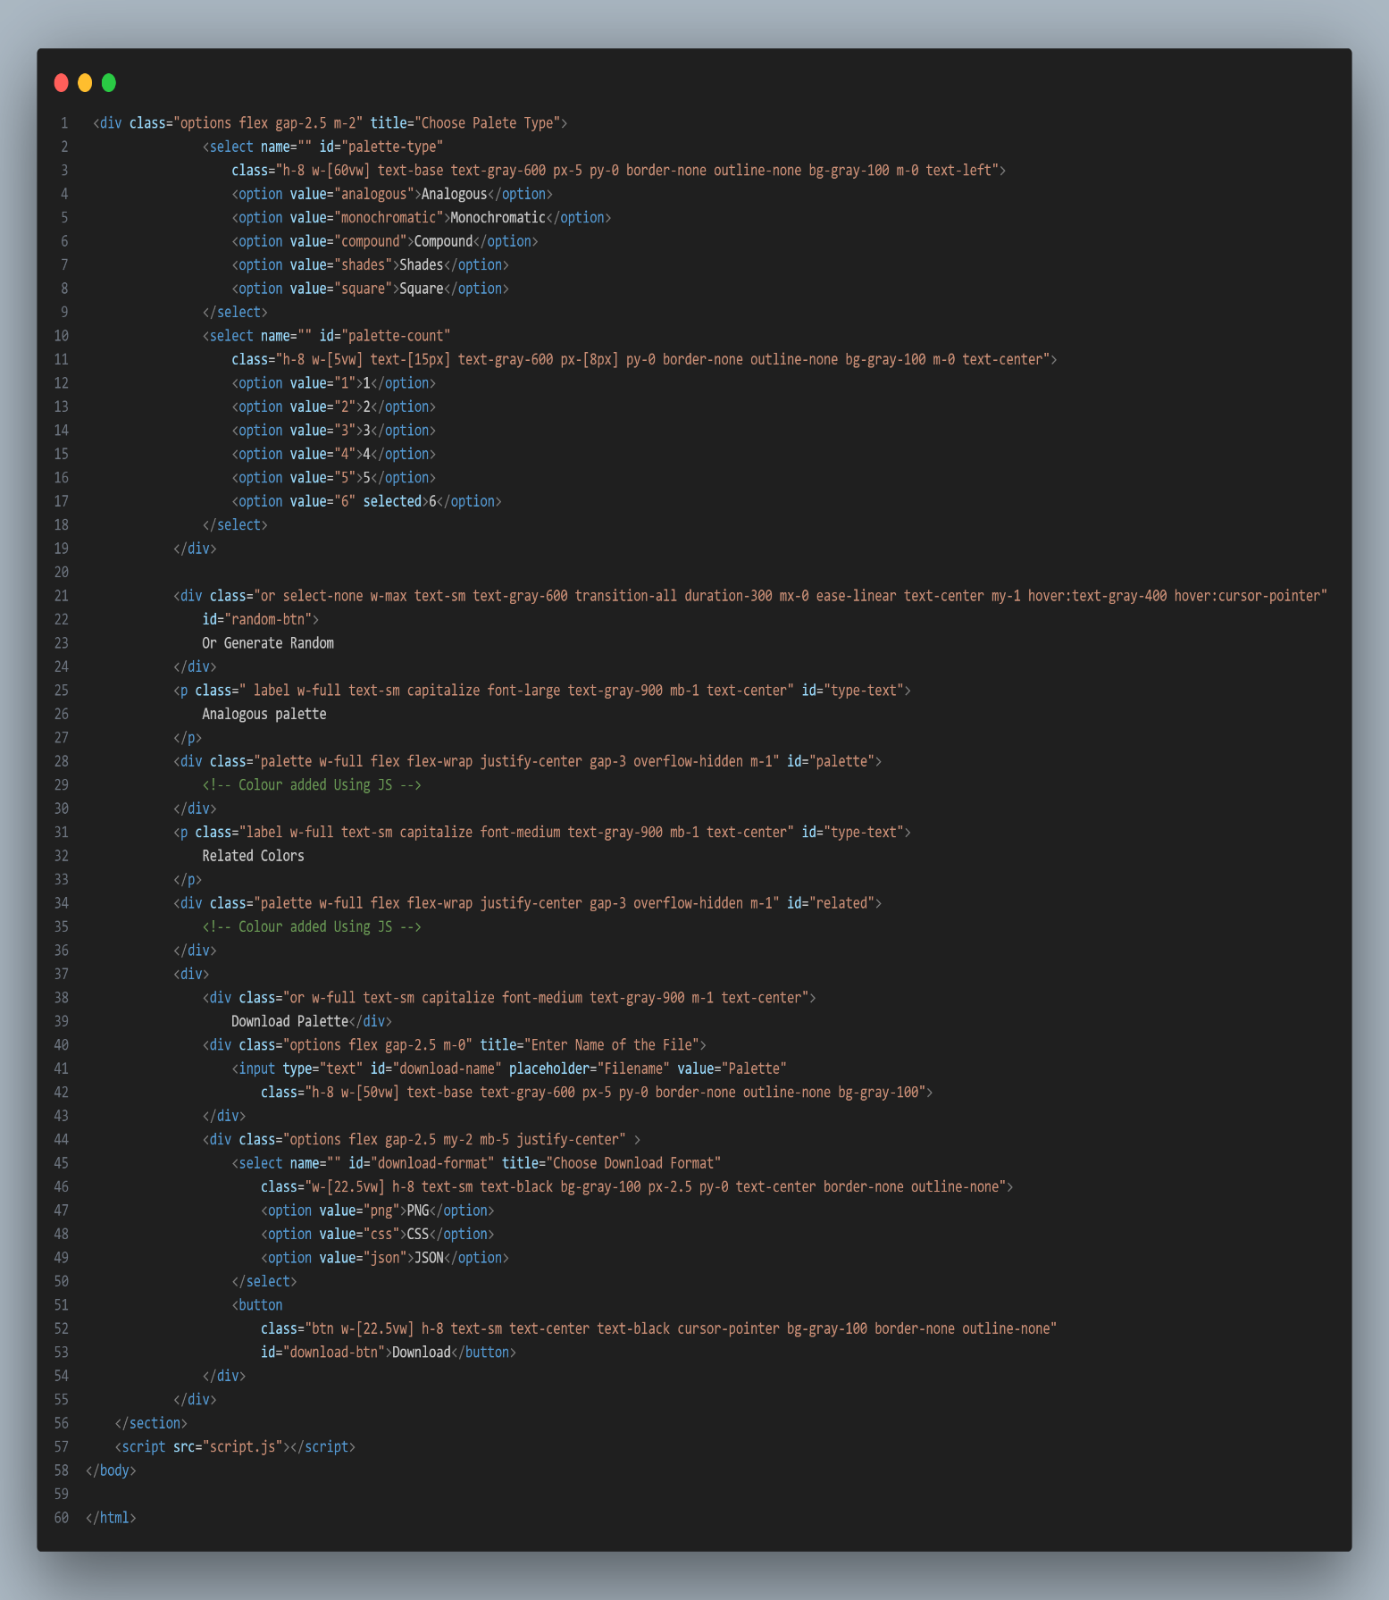

**Figure 3 HTML Body**

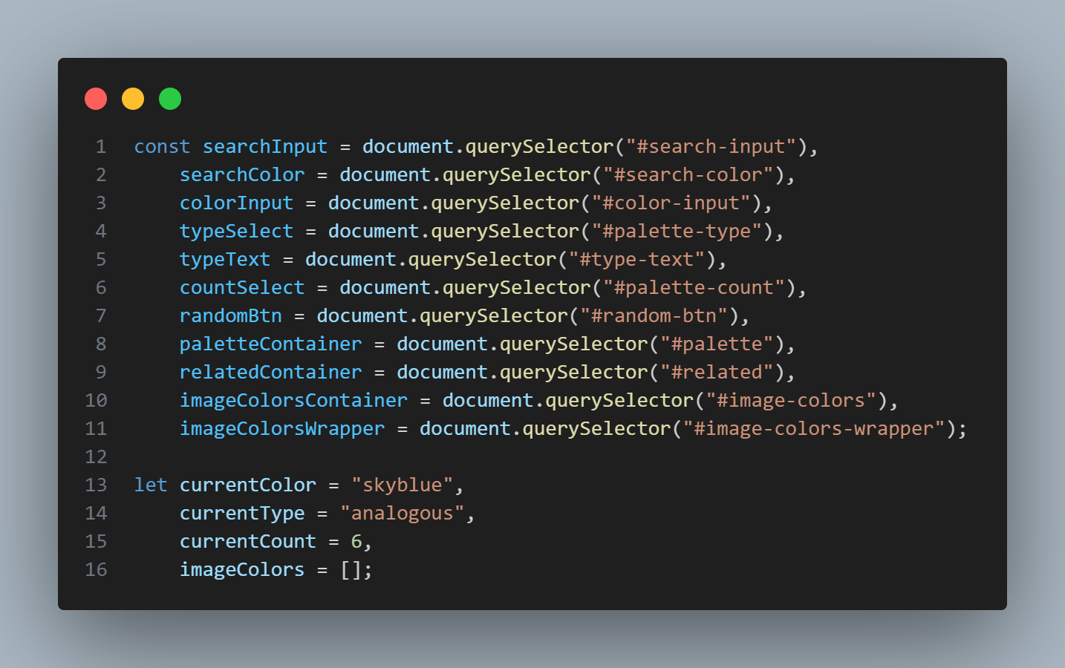

**Figure 4 Javascript**

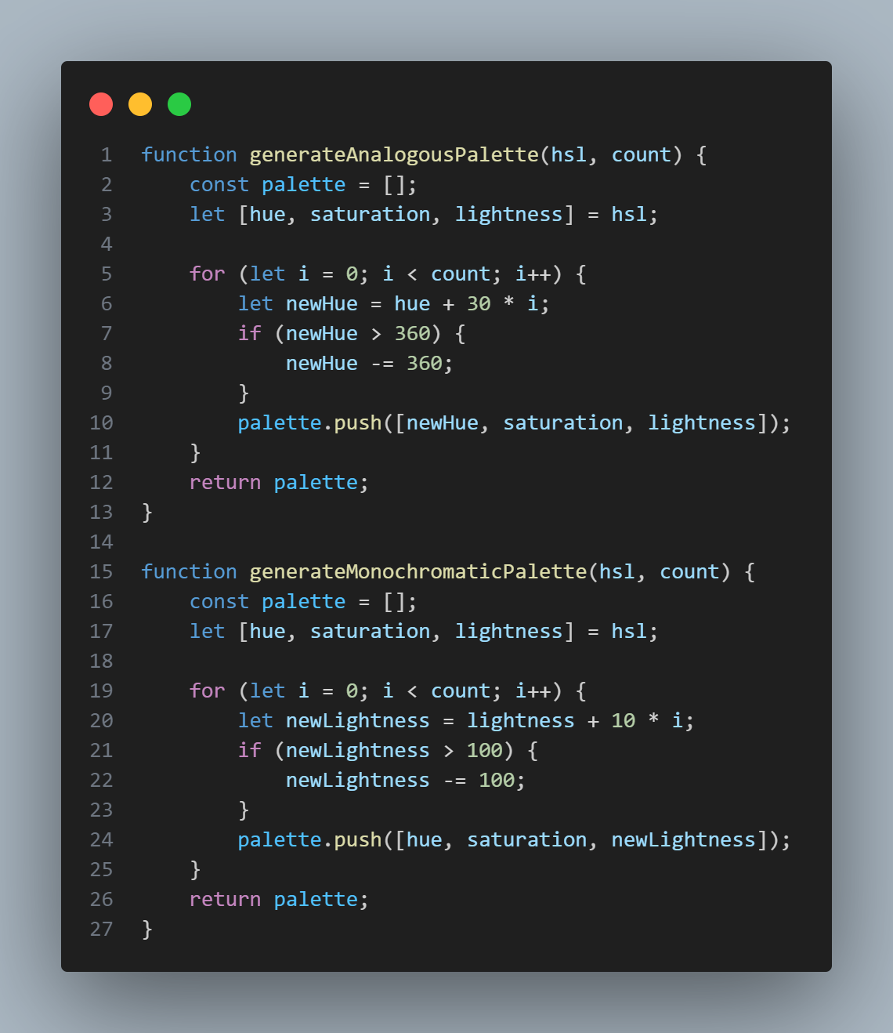

**Figure 5 Javascript**

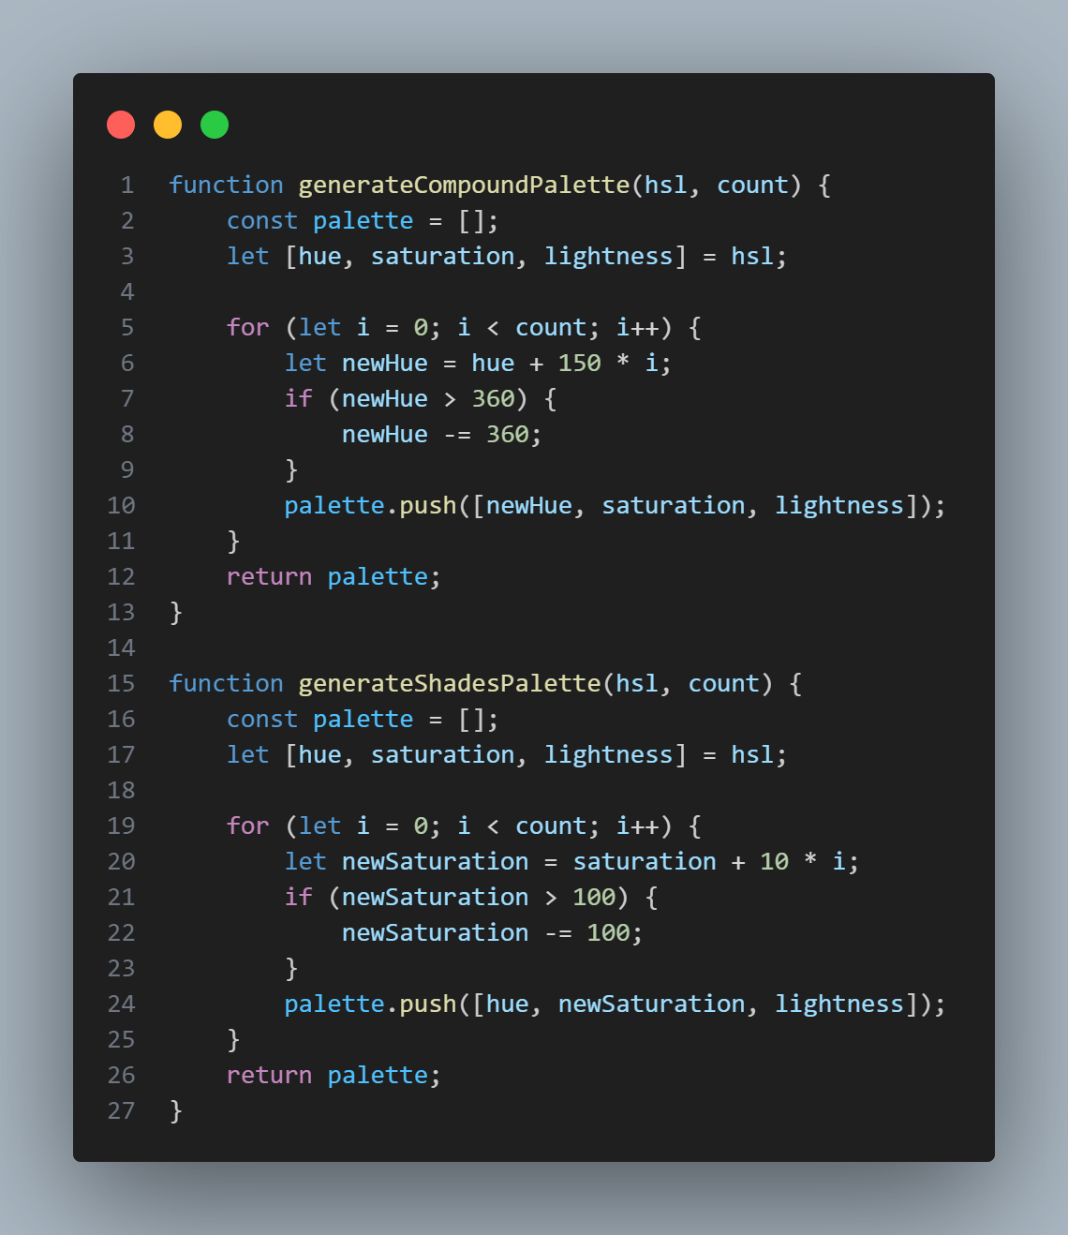

**Figure 6 Javascript**

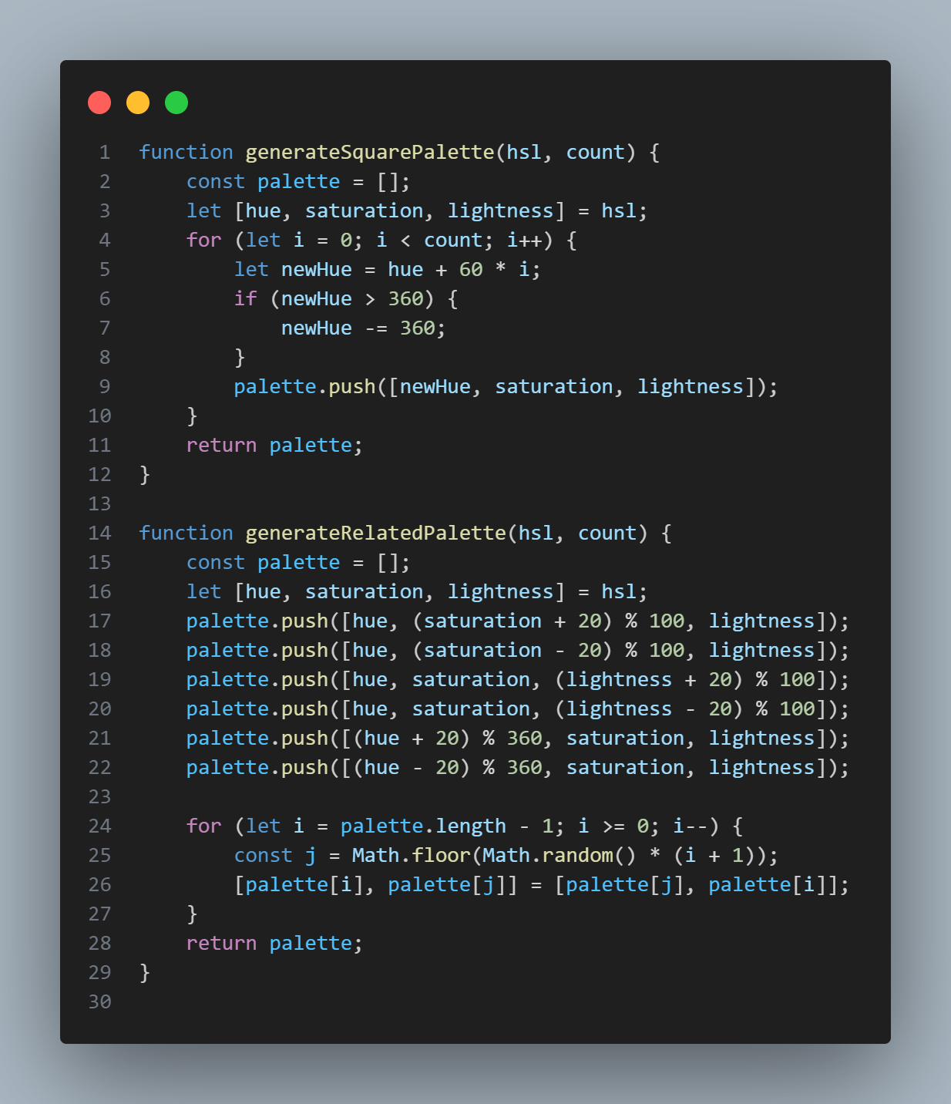

**Figure 7 Javascript**

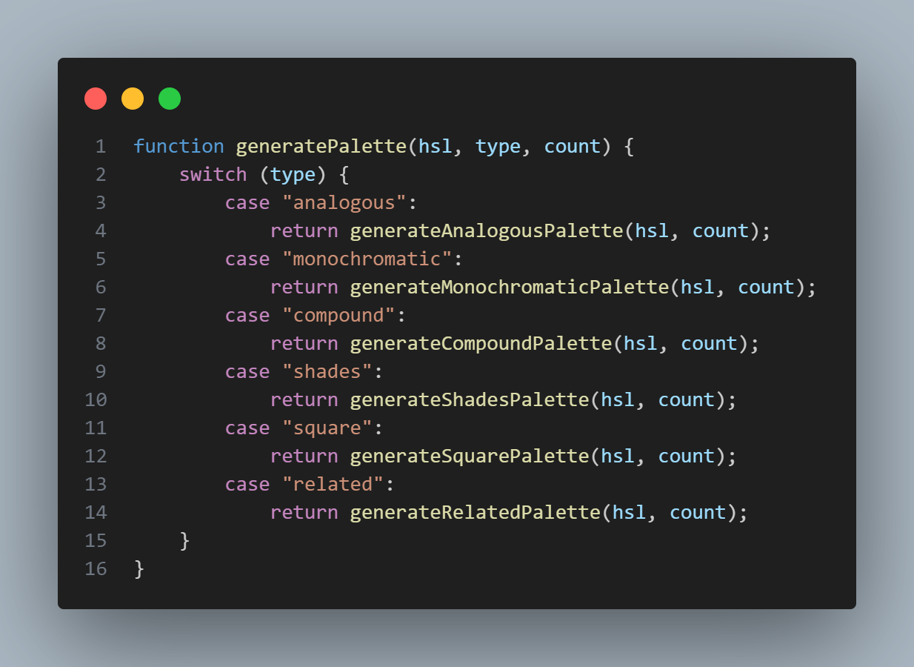

**Figure 8 Javascript**

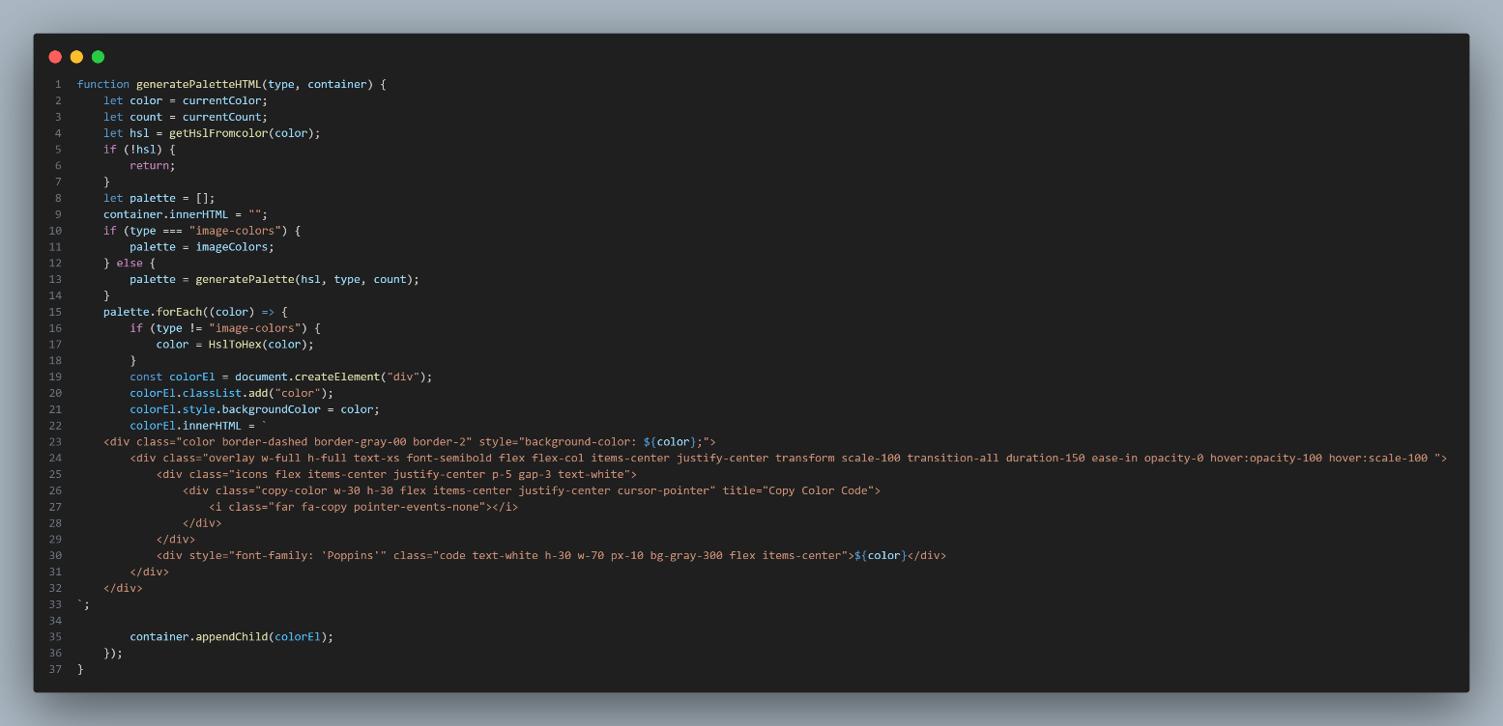

**Figure 9 Javascript**

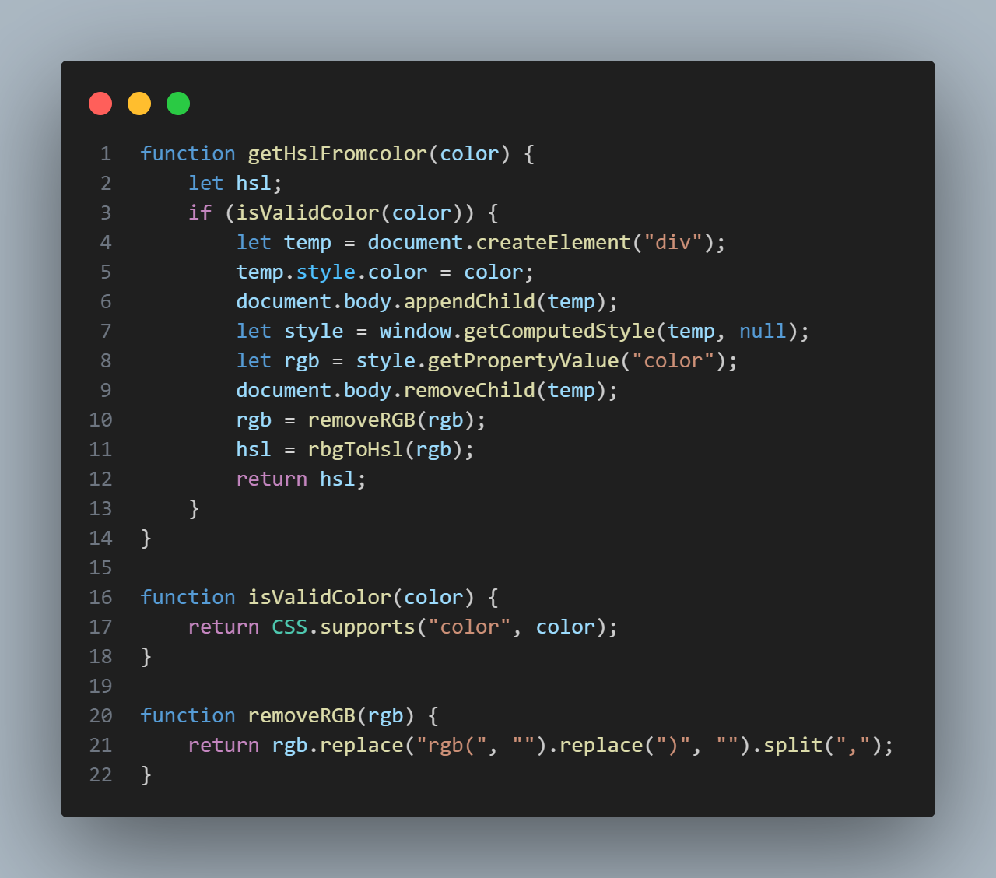

**Figure 10 Javascript**

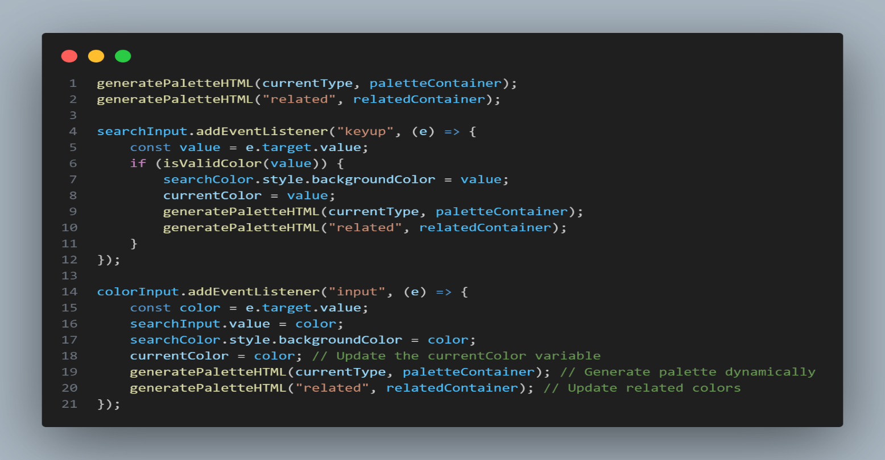

**Figure 11 Javascript**

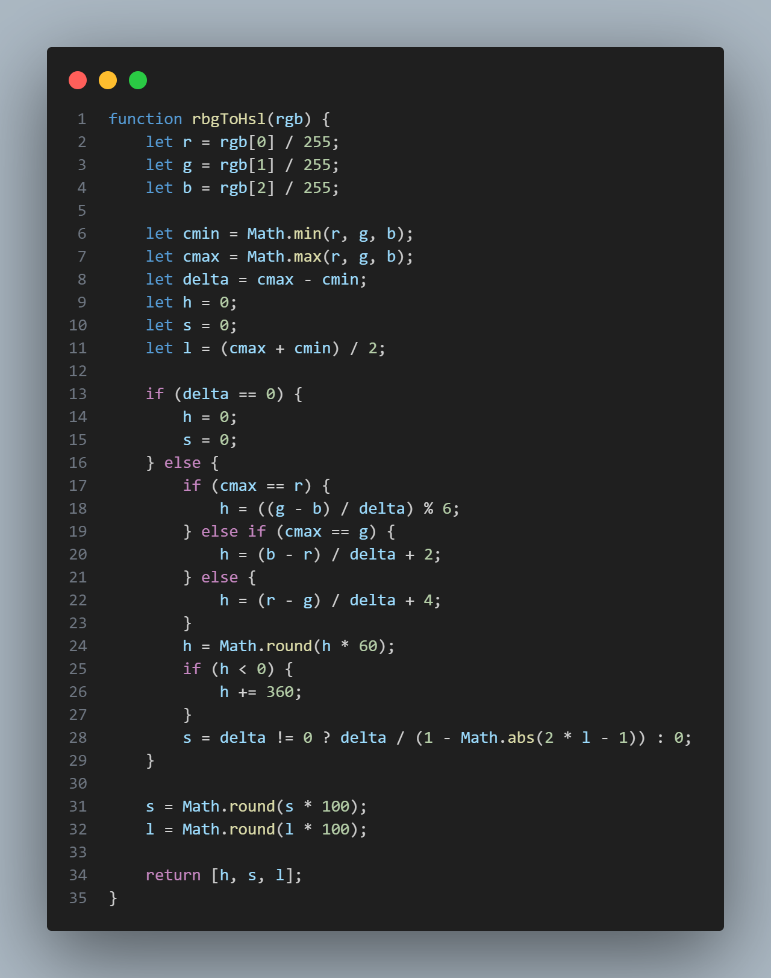

**Figure 12 Javascript**

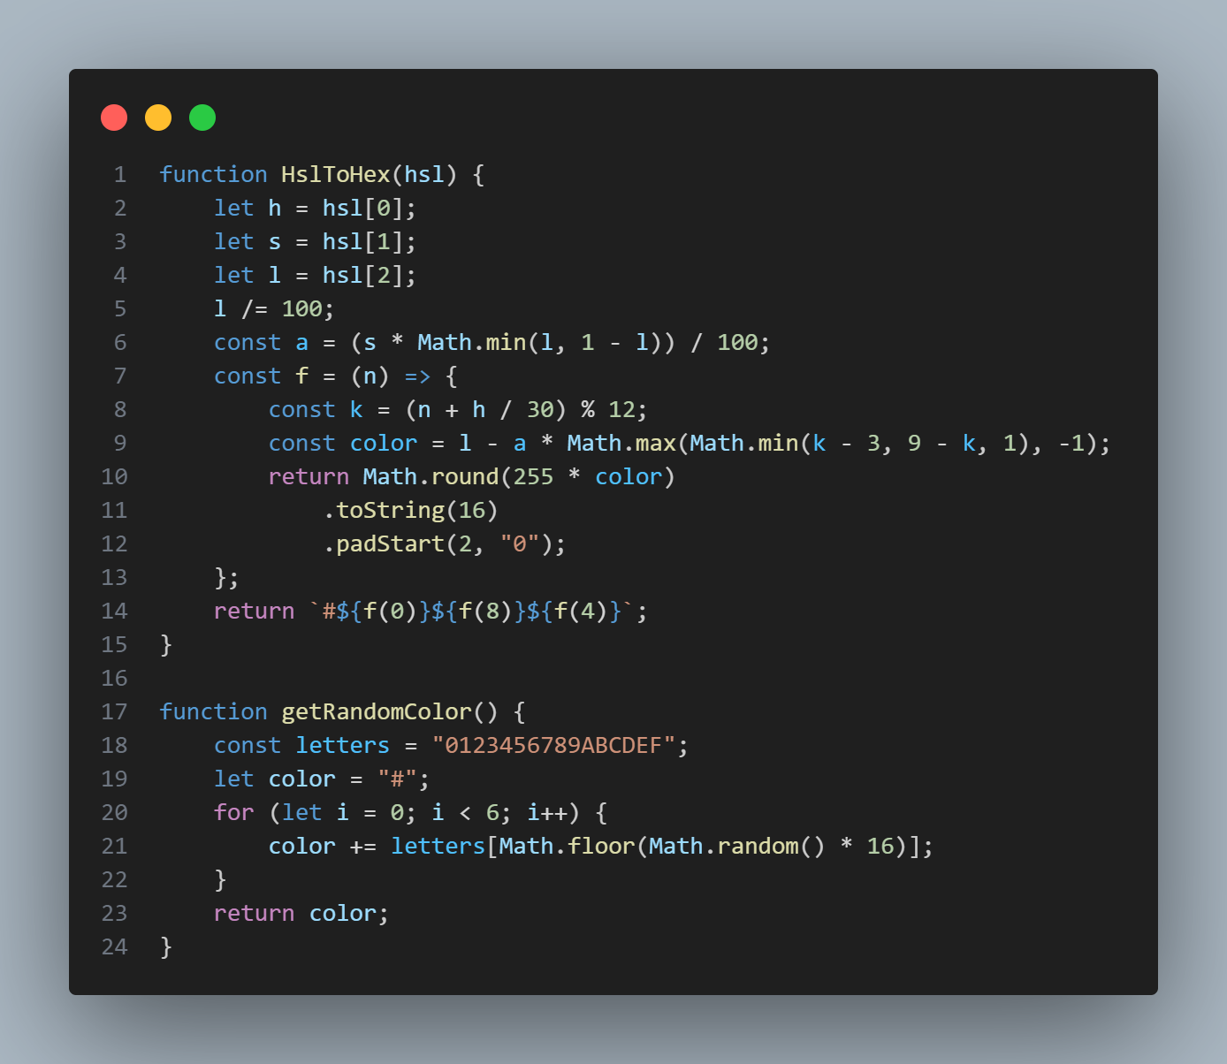

**Figure 13 Javascript**

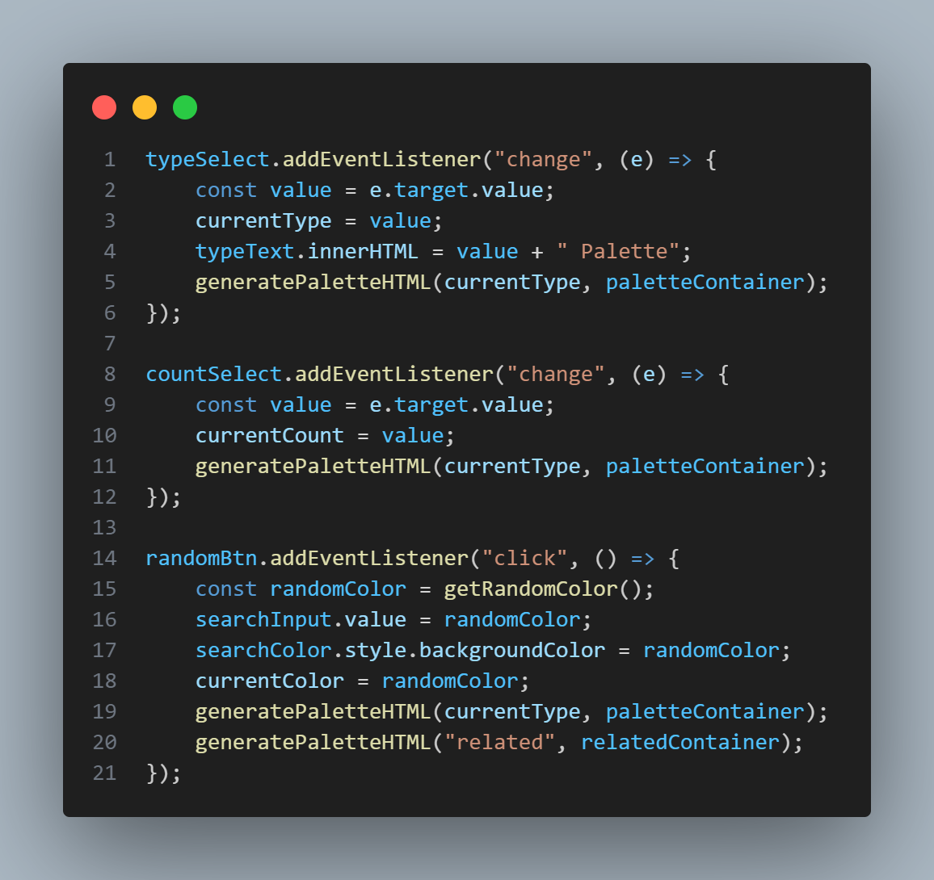

**Figure 14 Javascript**

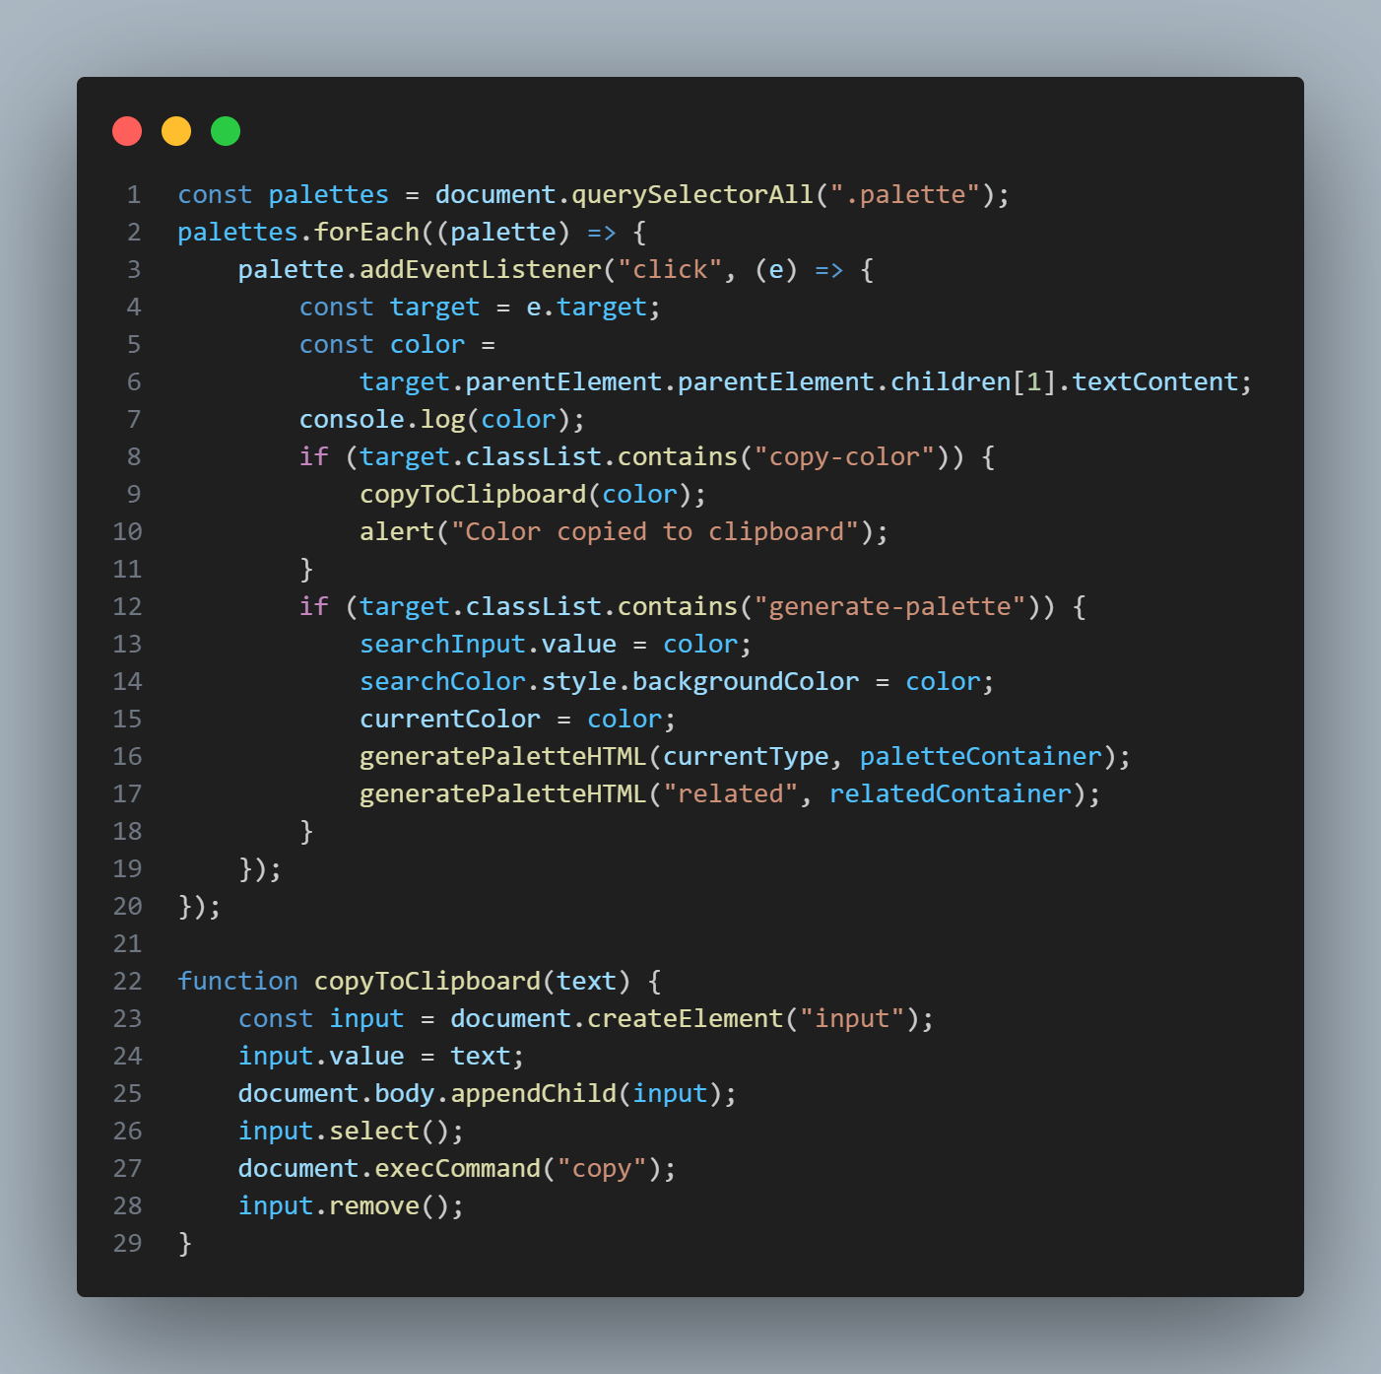

**Figure 15 Javascript**

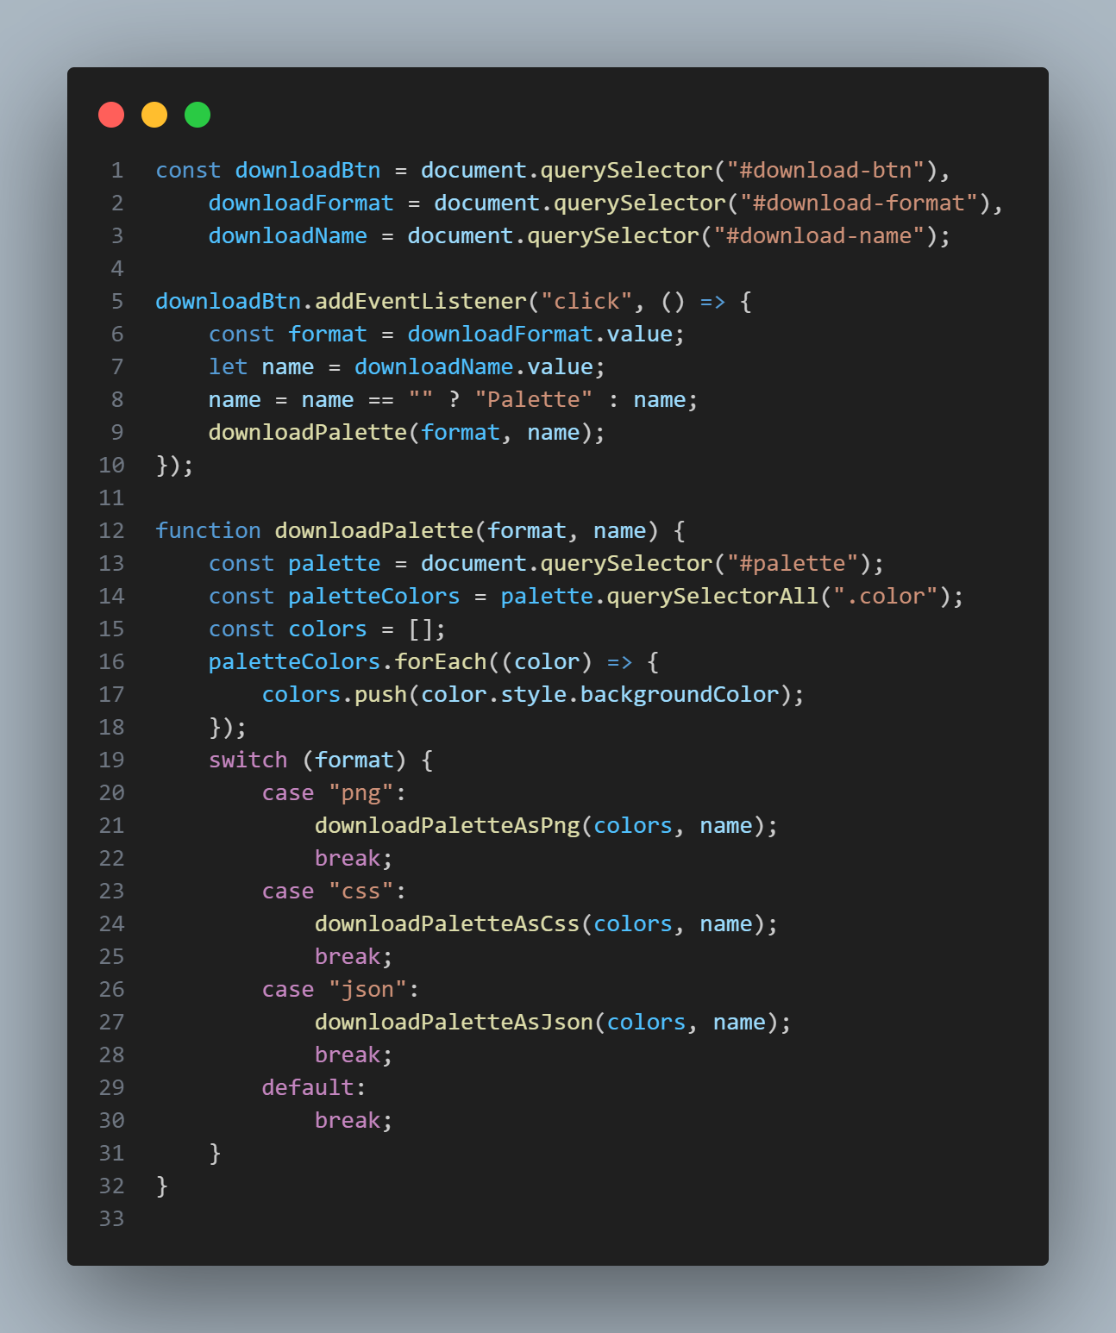

**Figure 16 Javascript**

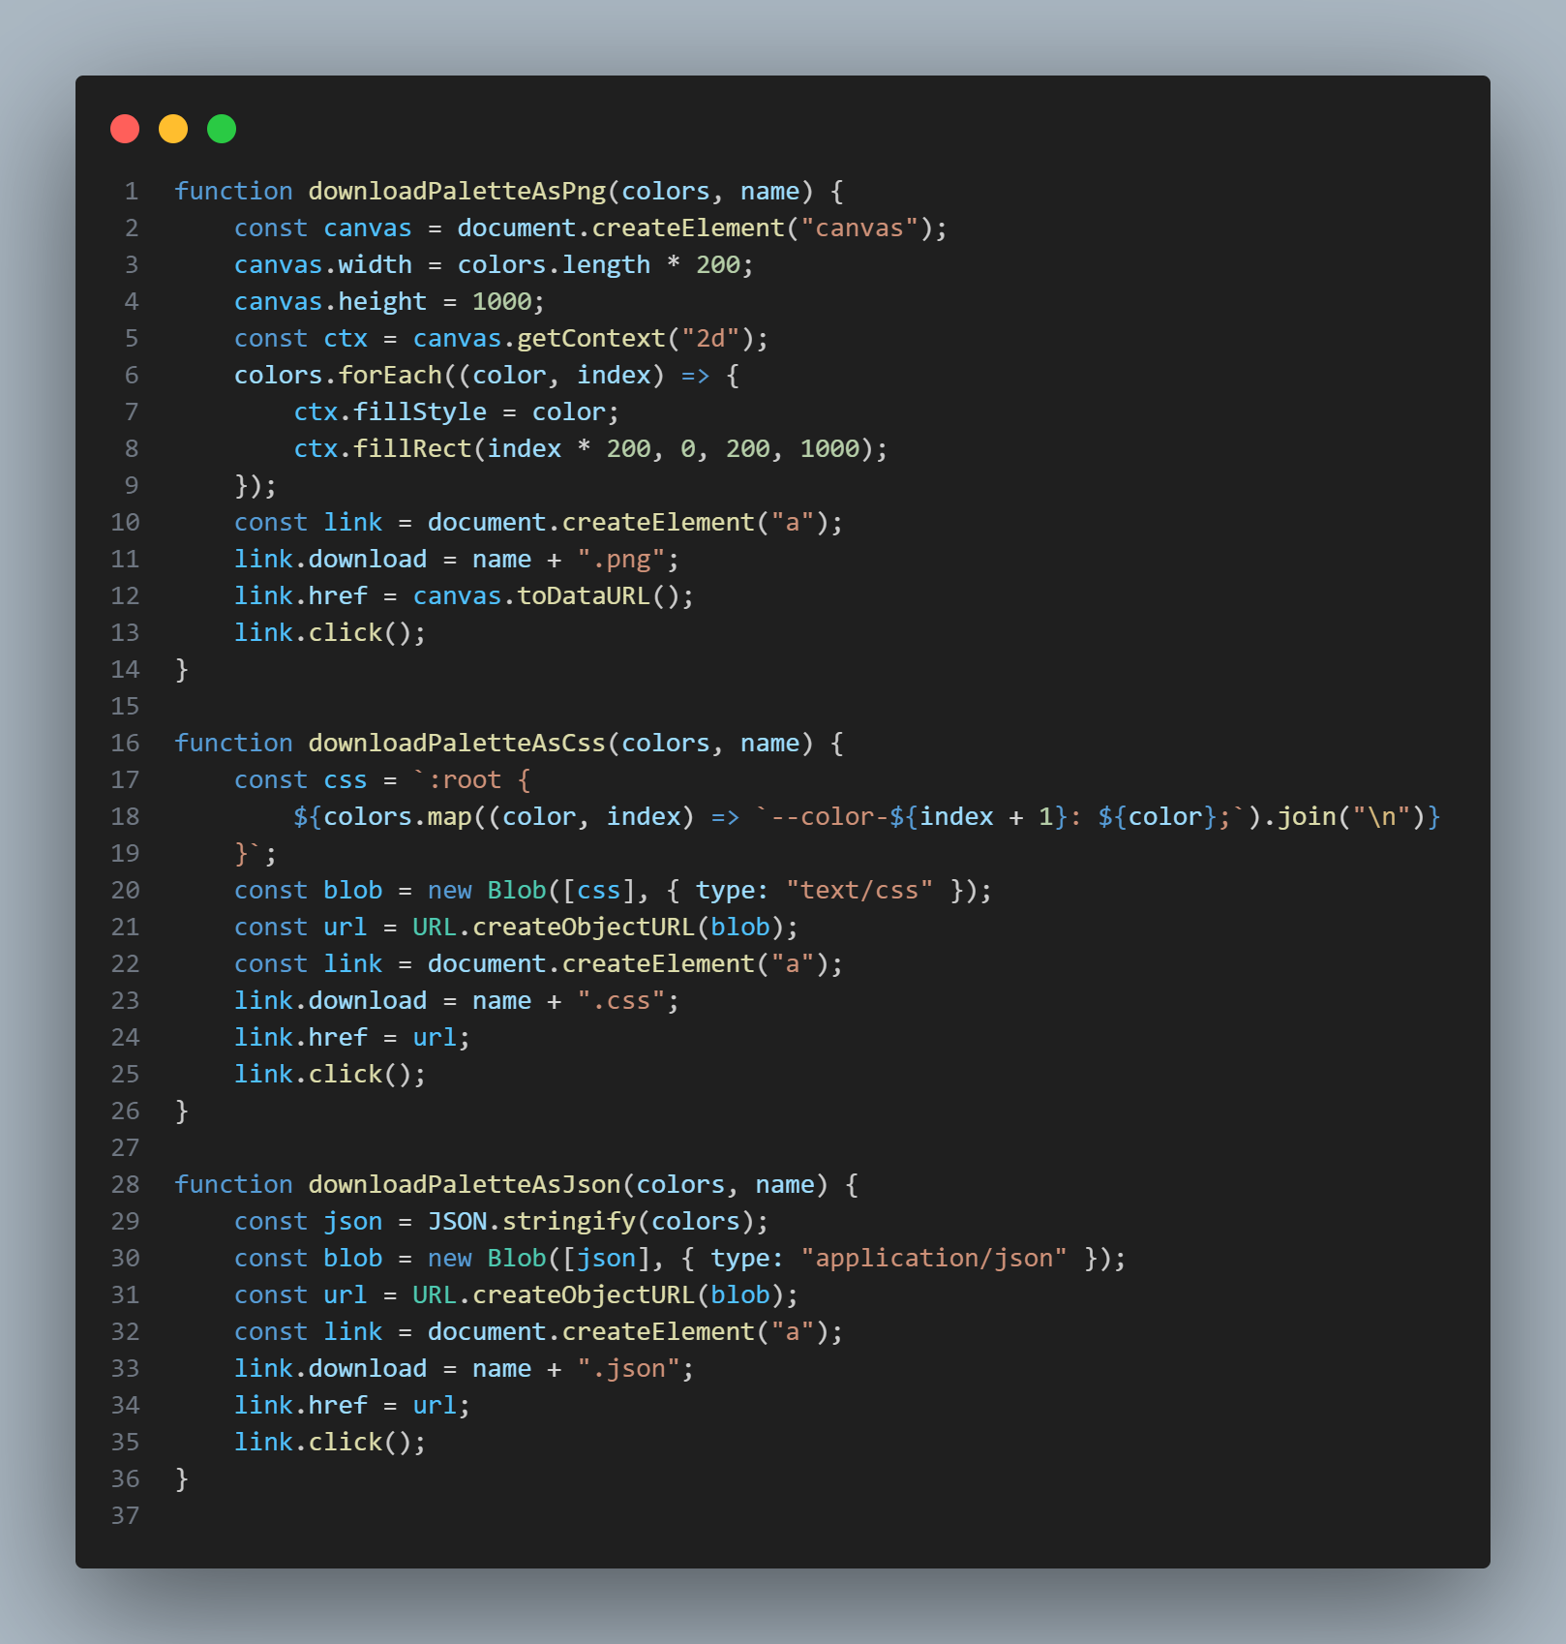

**Figure 17 Javascript**

# References

1. <https://www.w3schools.com/>
2. <https://fonts.google.com/>
3. <https://tailwindcss.com/>
4. <https://cdn.tailwindcss.com>
5. <https://cdnjs.cloudflare.com/ajax/libs/font-awesome/6.3.0/css/all.min.css>